**Introduction of SMSA**

Soochow University Medical Students’ Association (SMSA), founded on the 29th of December, 2014, is one of the 15 local committees of IFMSA-China. It aims to expose medical students of Soochow University to humanitarian and global health issues, to give them the opportunity to take part in clinical and research exchanges worldwide and to help provide a network that links active medical students across the globe.

The International Federation of Medical Students Associations (IFMSA), founded in 1951, is one of the world’s oldest and largest student-run organizations. It represents, connects and engages every day with an inspiring and engaging network of 1.3 million medical students from 130 national member organizations in 122 countries worldwide. IFMSA brings people together to exchange, discuss and initiate projects to create a healthier world. Now, it is recognized as a non-governmental organization within the United Nations system and the World Health Organization, and also works with the World Medical Association.

IFMSA-China, founded in 2009, aiming to provide domestic and international communications among medical students in China, and having established a platform where medical students can improve themselves, call for social awareness and make a difference. Since 2009, IFMSA-China has been animated on the world stage. Hundreds of Chinese medical students got the chance to improve their professional/research knowledge abroad, at the same time, foreign medical students came to China to learn and communicate. Besides, the representatives of IFMSA-China presented our achievements on General Assembly of IFMSA, which were praised and appreciated by medical students around the world.

SMSA is composed of 5 standing committees (SCOME, SCOPE, SCORE, SCOPH, SCORA), publicity and secretariat.

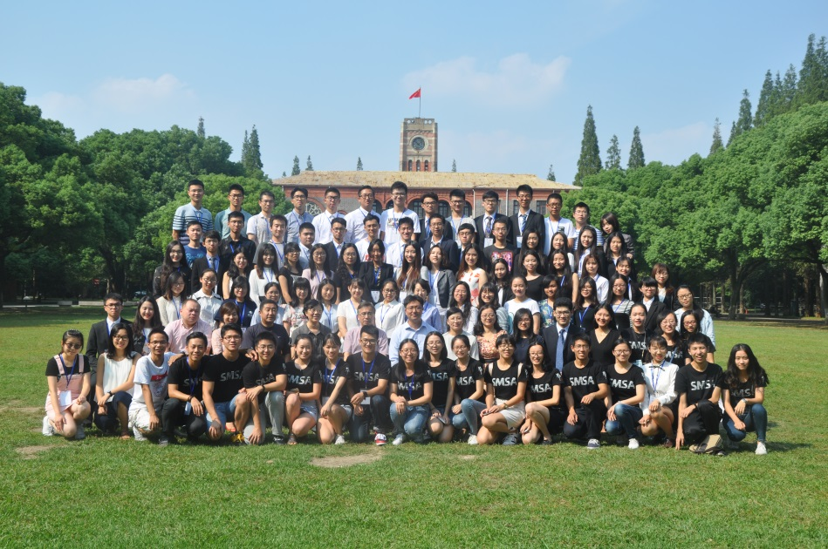

**The 4th National Meeting of IFMSA-China in Soochow University**

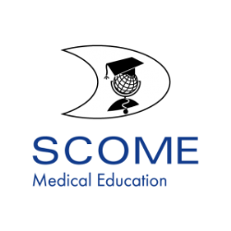**Welcome to SCOME!**

Medical Education should be a concern of every medical student as it shapes not only the quality of future doctors, but also the quality of healthcare. IMFSA has a dedicated organ which aims to implement an optimal learning environment for medical students. Through all our joint efforts we work to create sustainable changes, for ourselves as medical students, for the generations to come and for our future patients and our communities who are in fact the final beneficiaries of our education.

**Vision**Medical students attain an optimal professional and personal development to reach their full potential as future doctors for better health care worldwide.

**Mission**Our mission is to be the frame in which medical students contribute to the development of medical education. Students convene in SCOME to share and learn about medical education in order to improve it as well as benefit the most from it on a personal and professional basis.

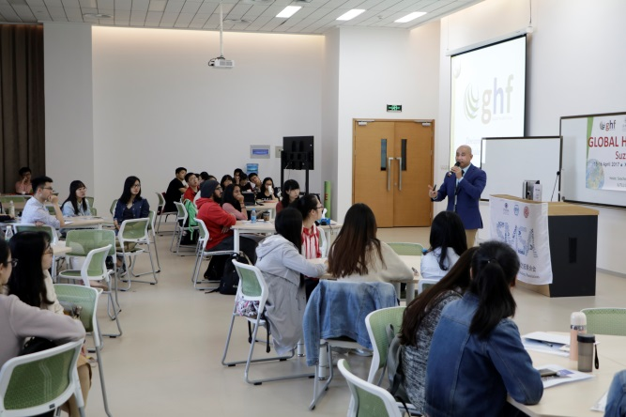**Our Achievements**

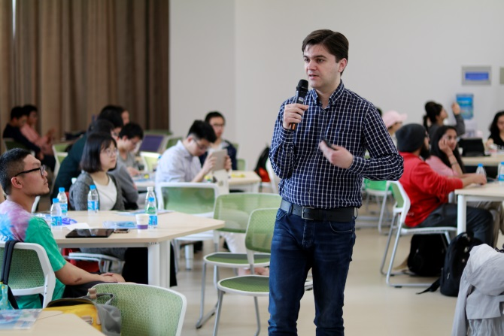

### 

Global Health Course

Global Health Course

### 

USMLE Sharing

USMLE Sharing

Training **Camp**

### Welcome to SCOPE!

The Professional Exchange program is a full educational program offering clerkships to medical students abroad. Since the very beginning, in 1951, it was evident that exchange of medical students would be one of the main fields of action in IFMSA. As early as 1952, a total of 463 students spent a period of practice abroad, and today, it continues to be the backbone of the federation and constitutes its longest running project. Annually, more than 13.000 students from 90 countries travel around the world to discover new health systems, new cultures and to enhance their global health and intercultural understanding.

**Mission**The aim of SCOPE is to promote cultural understanding and co-operation amongst medical students and all health professionals, through the facilitation of international student exchanges. SCOPE aims to give all students the opportunity to learn about global health, and attains this partly by having its exchanges accredited by medical faculties across the world.

**Our Achievements**

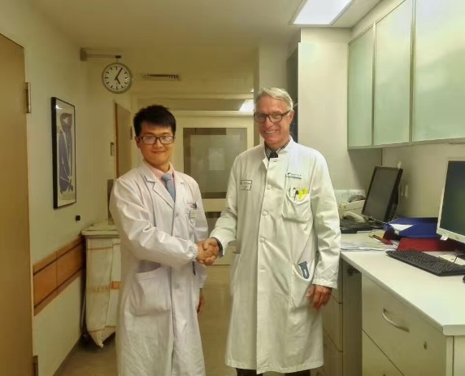**Outgoing:**

**Zheng Kai, Spanish, 2017**

**Ge Jun, Germany, 2017**

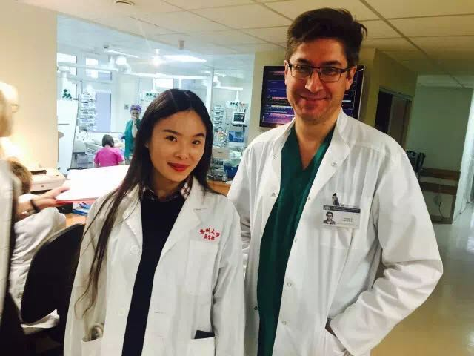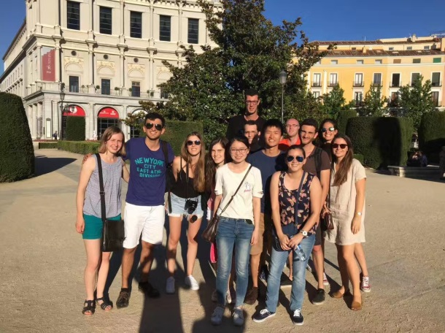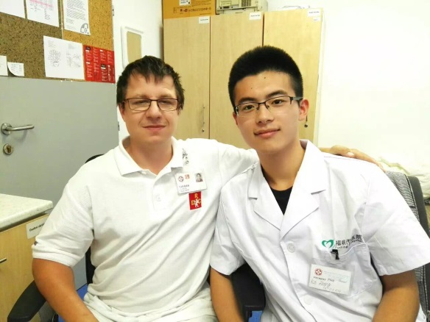

**Jiang Tingting, Spanish, 2017**

**Xi Qianlan, Republic of Lithuania, 2016**

①

**Incoming:**

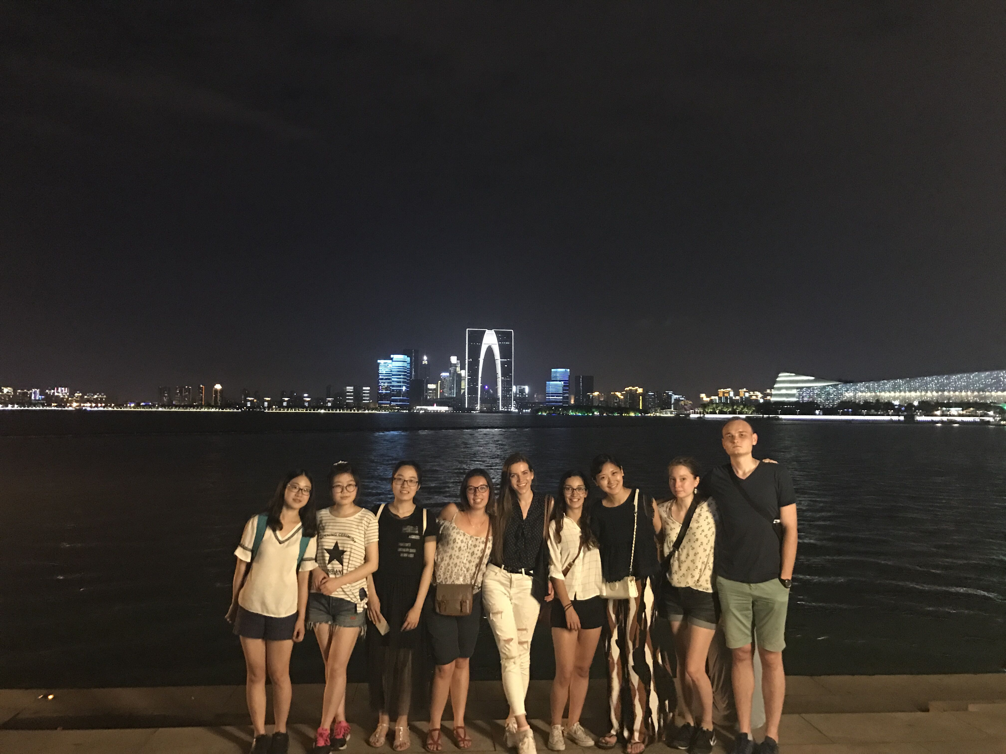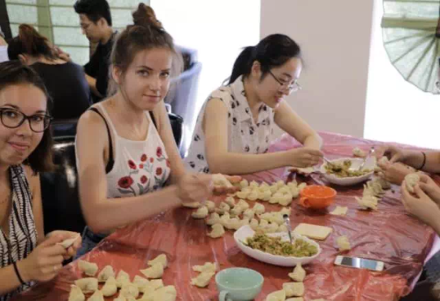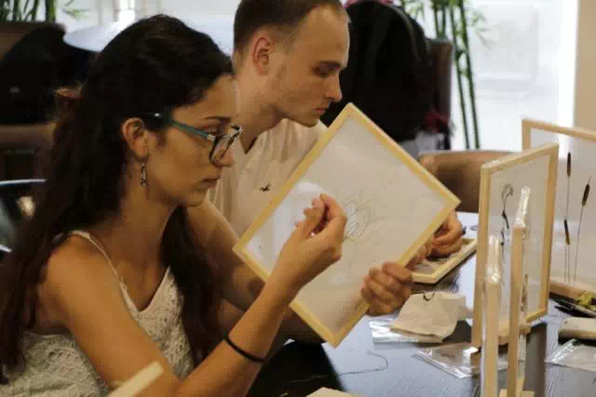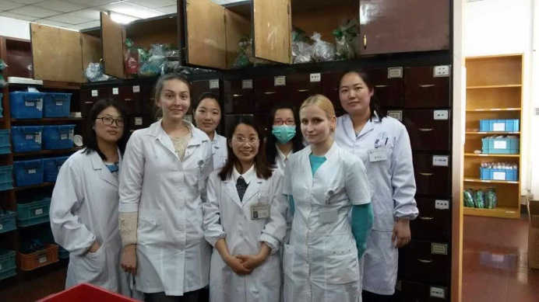

### Welcome to SCORE!

Unfortunately several times we don’t have the opportunity as medical students to have a research experience while in the medical school. Research is essential for the development of medicine and without it the medical fields could never have reached the stage they are right now with innovative methods of diagnosis and treatments. Join the experience of improving the research skills with an unforgettable cultural learning and you have the Standing Committee on Research Exchange.

**Mission**Our mission is to offer future physicians an opportunity to experience research and diversity in countries all over the world. This is achieved by providing a network of locally and internationally active students that globally facilitate access to research exchange projects. Through our programming and opportunities, we aim to develop both culturally sensitive students and skilled researchers intent on shaping the world of science in the upcoming future.

**Our Achievements**

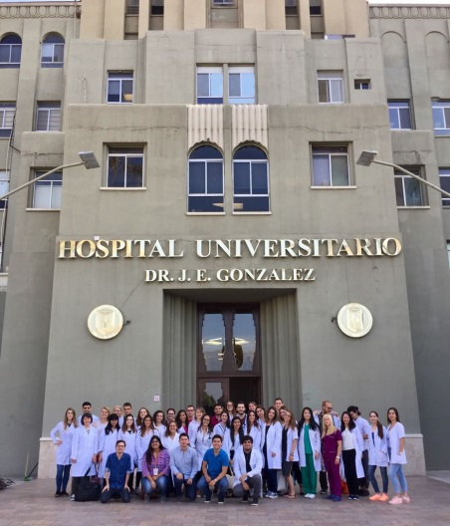**Outgoing:**

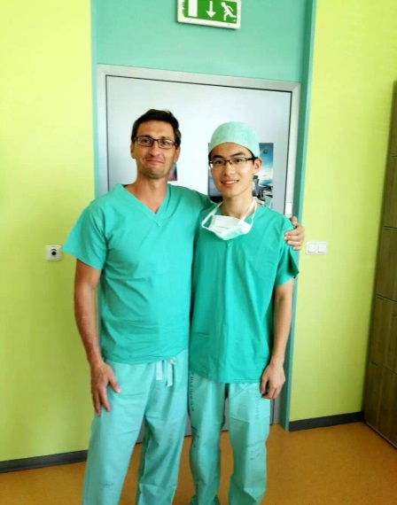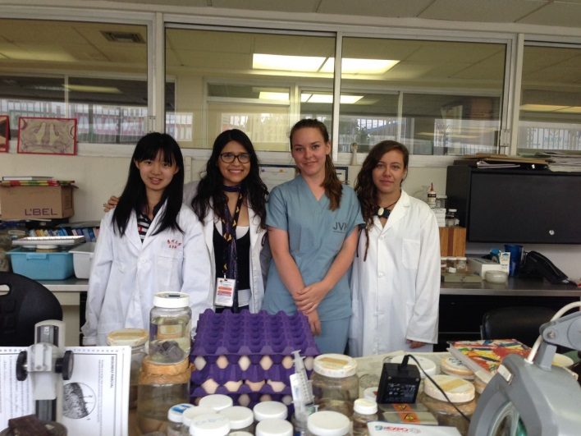

**Xue Lihong, Mexico, 2017**

**Zheng Kai, Czech Republic, 2016**

**Xiao Jiarui, Czech Republic, 2017**

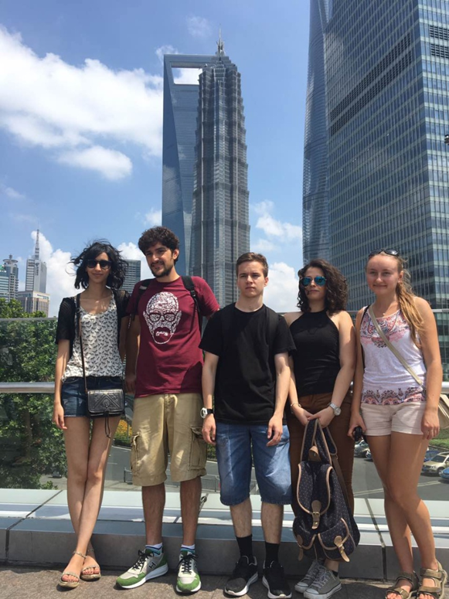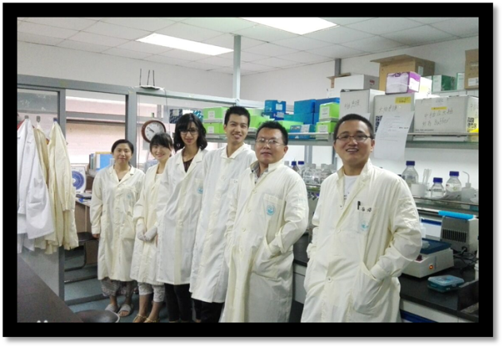**Incoming:**

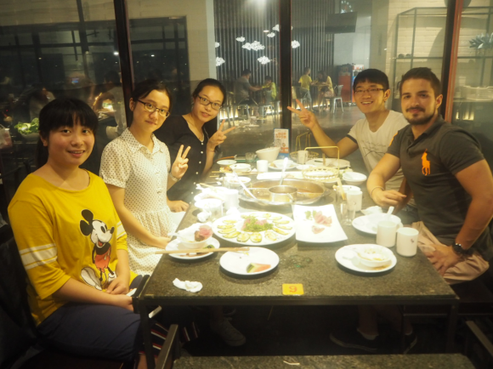

### Welcome to SCOPH!

The Standing Committee on Public Health (SCOPH) brings together medical students from all over the world to learn, build skills, cooperate, explore and share ideas when it comes to addressing all issues related to public health, including global health issues, health policies, health promotion and education, activities.

**Vision**The Standing Committee on Public Health aims to become a reference as training and learning pillars for medical students, in order to create future public health qualified leaders who are equipped with the knowledge, skills and values to work on a local and an international level.

**Mission**The Standing Committee on Public Health promotes the development of medical students worldwide regarding public health issues through an international sharing knowledge network, projects management, community based learning, capacity building, advocacy and access to external learning opportunities.

**Our Achievements**

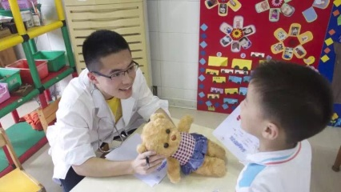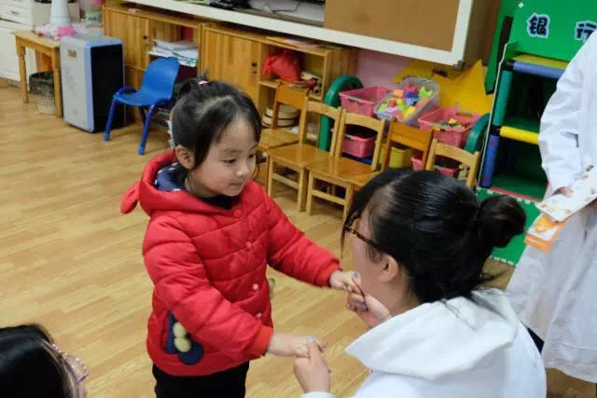

**CPR Flash**

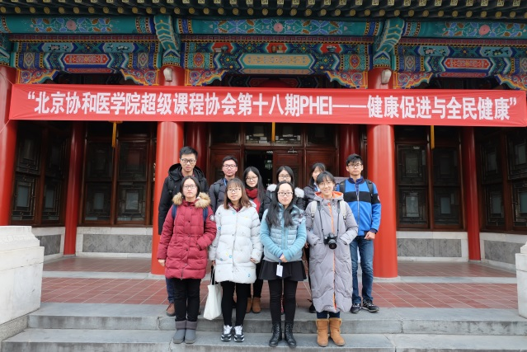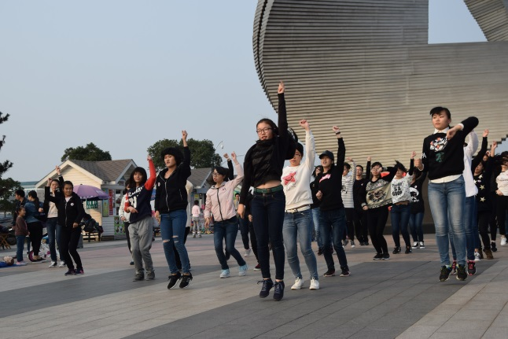

**PHEI**

**CPR Flash Mod**

**Teddy Bear Hospital**

**Teddy Bear Hospital**

**PHEI**

### Welcome to SCORA!

Standing Committee on Sexual and Reproductive Health including HIV/AIDS is gathering passionate individuals who are committed to promote sexual and reproductive health and rights and are passionate about creating positive change in their local communities.

**Vision**A world where every individual is empowered to exercise their sexual and reproductive health rights equally, free from stigma and discrimination.

**Mission**To provide our members with the tools necessary to advocate for sexual and reproductive health and rights within their respective communities in a culturally respected fashion. This has been accomplished through building the skills and the knowledge about, providing trainings on Comprehensive Sexuality Education other respective reproductive health issues, exchanging ideas and projects, as well as drafting policies and working with our external partners in order to create change in local, regional and international level.

**Our Achievements**

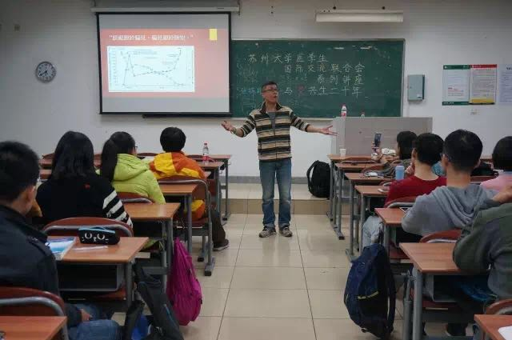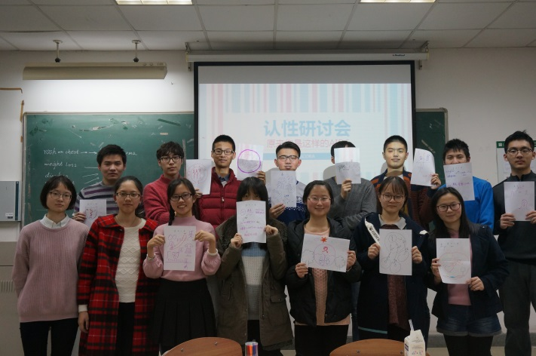

**AIDS sharing by Jinxiong Zhang**

**Workshop on sexual education**